view to calculate Historical CLTV (AOV * Purchase Frequency)

The table breaks down total customers, orders, revenue, average order value, purchase frequency, and calculated CLTV grouped across seven marketing acquisition channels.
QUERY-;
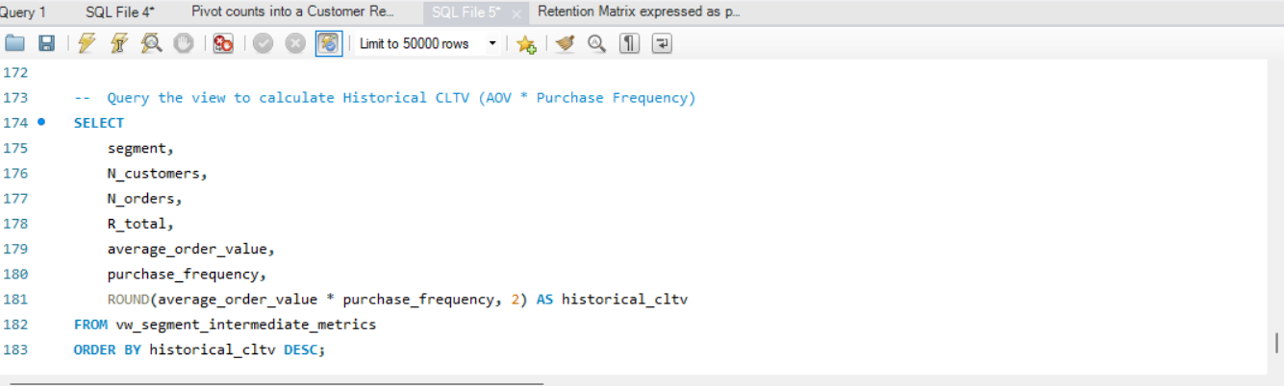

OUTPUT-;
